*Jahangirnagar University*

*Computer networking Lab*

*Lab-02*



Course Title: Computer Networking laboratory

Course Code: CSE-402

Submitted by:

Name: Md. Omar Faruque Abir

Roll: 44

Submitted Date : 05-09-2019

**Introduction:**

**Description:**

We used cisco packet tracer for simulation. Several computer devices are connected through the routers and different ip addresses were assigned to them. Then a packet is sent through them to check the characteristics of routers.we created a hop table to access networks that are far from the routers to pass the packets.

**Simulation:**

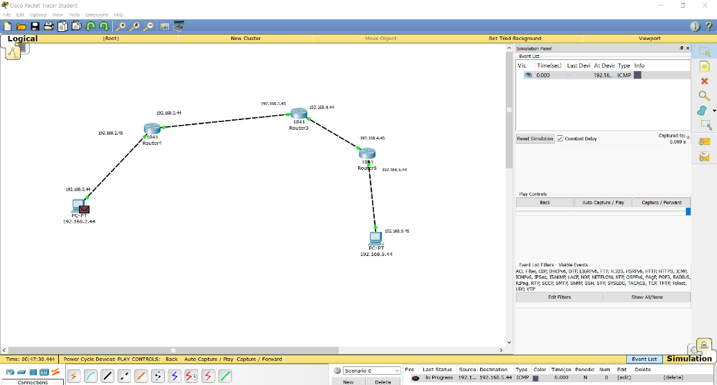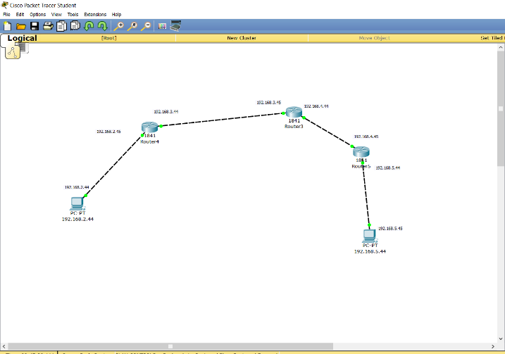

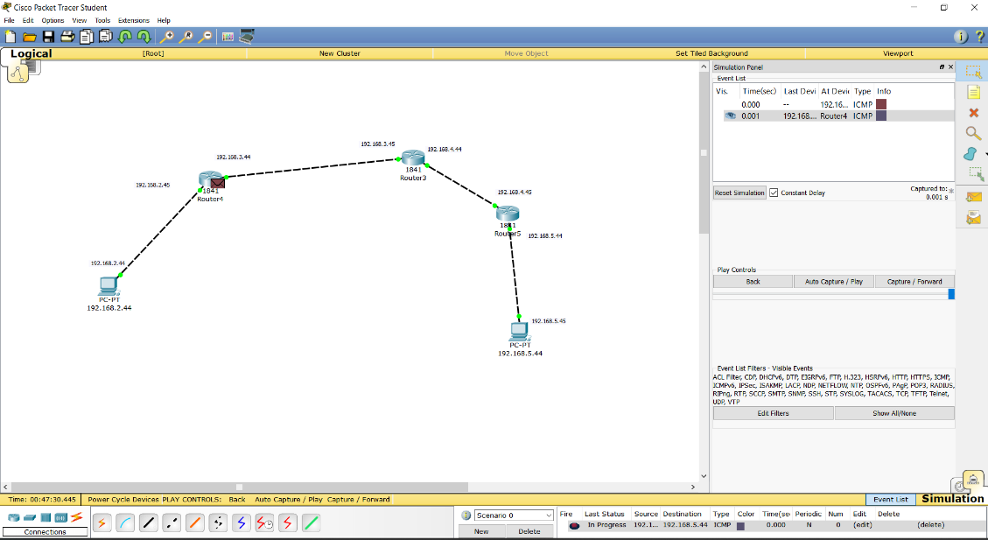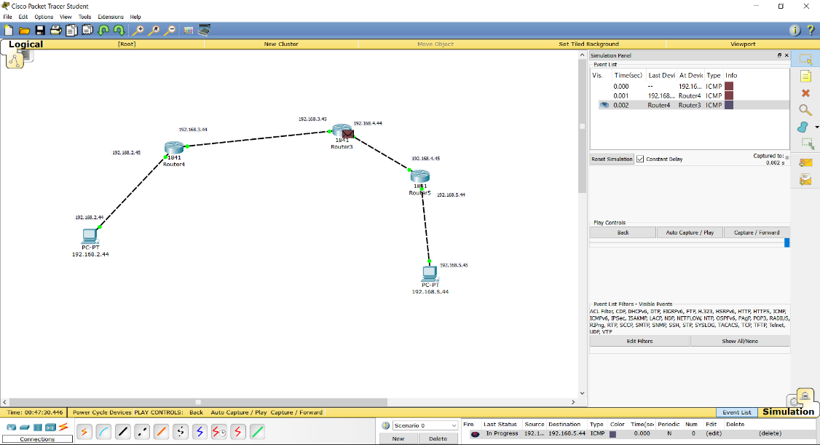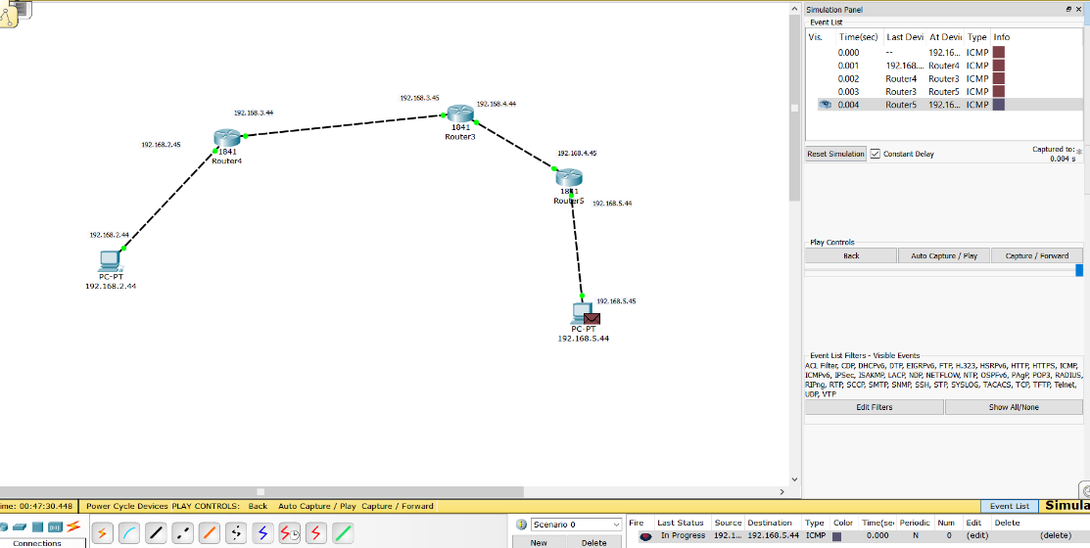

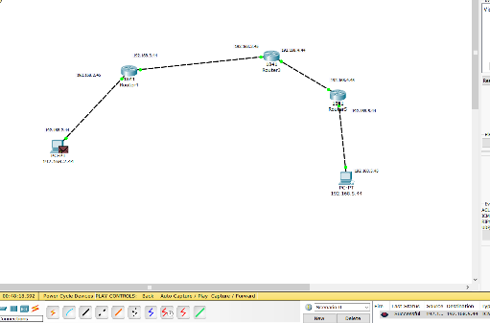

**Result:** We can see that the Routers sends the packet the required path mentioned in the rout table.

**Comment:** Using a table to determine hops is efficient.